1. 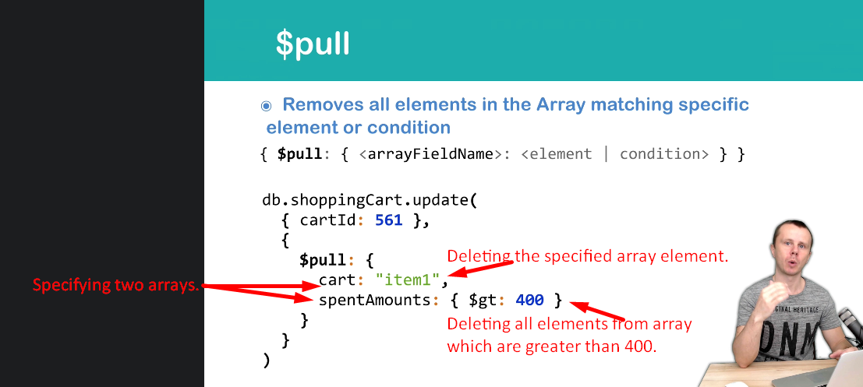
2. 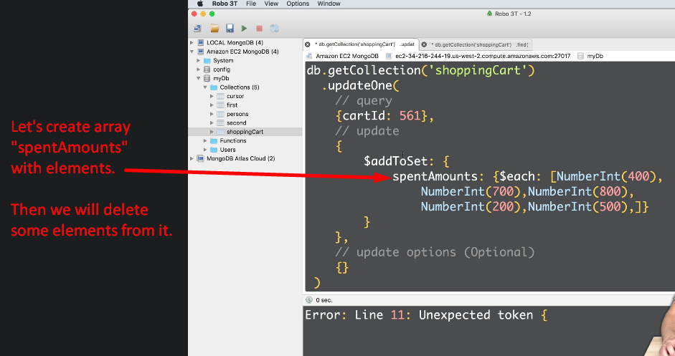
3. 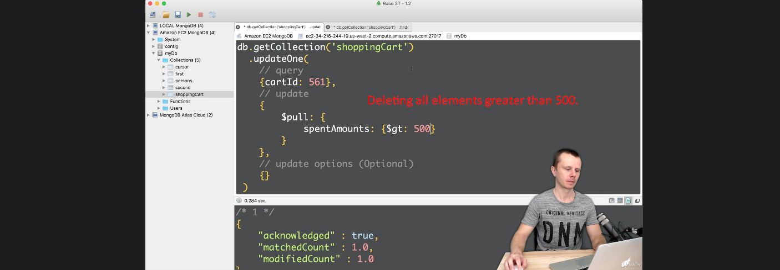
4. 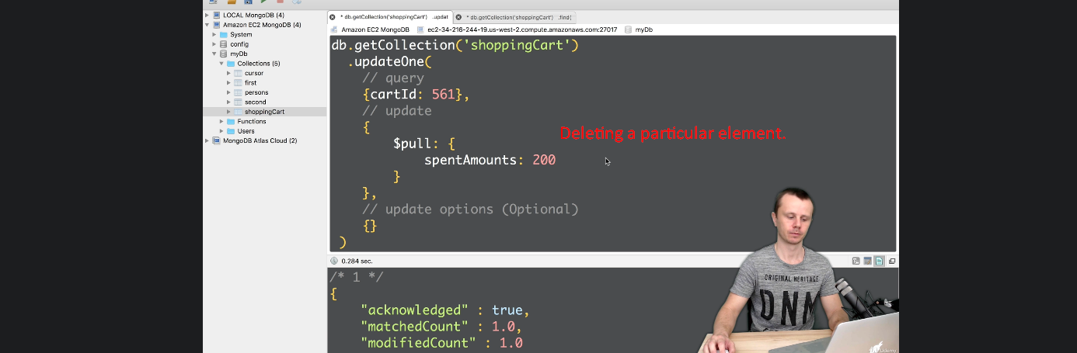
5. So, using $PULL, you can delete elements either by
   1. Querying
   2. Specific Value.